**7. Create Kubernetes Manifests for User Management Microservice Deployment**

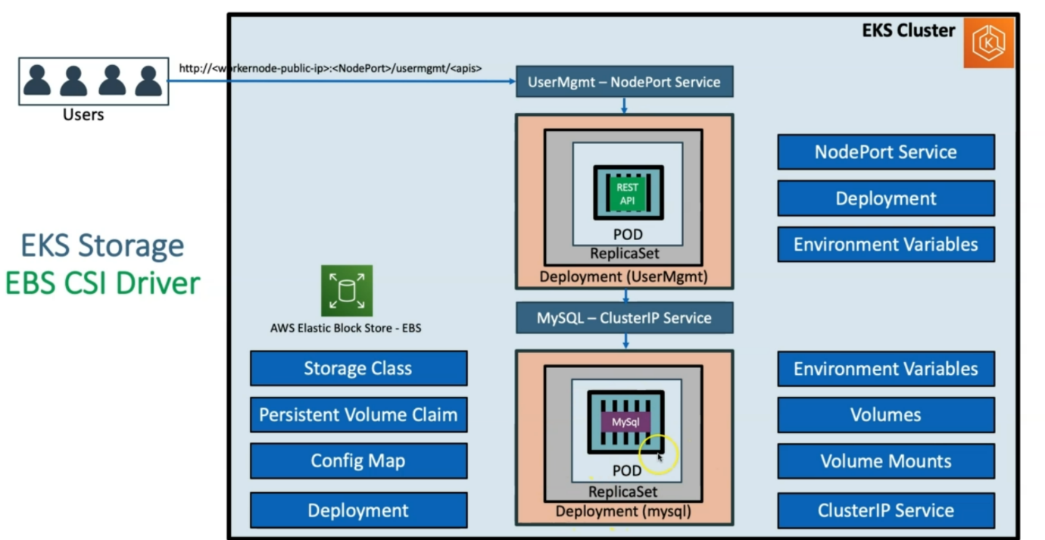

--- **note** – in this lecture we are going to create the deployment for the user management micro service and also, we are going to create the user management nodeport service.

--- we will also provide environmental variable required for this application to connect the mysql.

**Introduction**

--- We are going to deploy a User Management Microservice which will connect to MySQL Database schema usermgmt during startup.

Then we can test the following APIs

1. Create Users
2. List Users
3. Delete User
4. Health Status

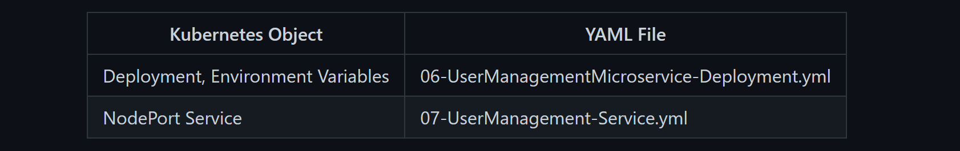

**Create following Kubernetes manifests**

**Create User Management Microservice Deployment manifest**

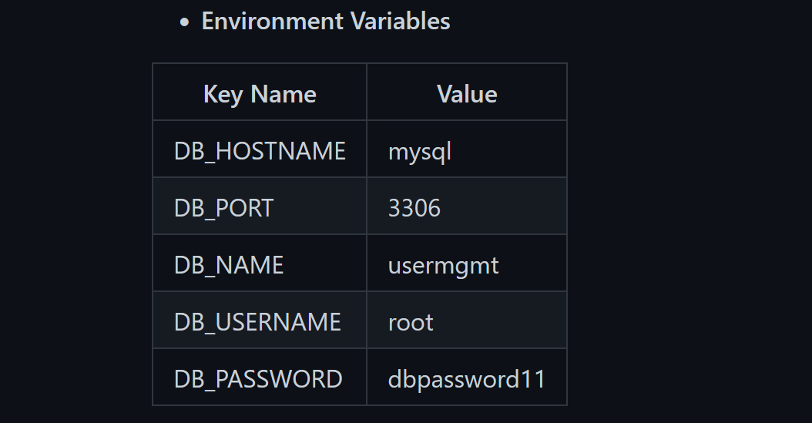

--- **06-UserManagementMicroservice-Deployment-Service.yml**

apiVersion: apps/v1

kind: Deployment

metadata:

  name: usermgmt-microservice

  labels:

    app: usermgmt-restapp

spec:

  replicas: 1

  selector:

    matchLabels:

      app: usermgmt-restapp

  template:

    metadata:

      labels:

        app: usermgmt-restapp

    spec:

      containers:

        - name: usermgmt-restapp

          image: stacksimplify/kube-usermanagement-microservice:1.0.0

          ports:

            - containerPort: 8095

          env:

            - name: DB_HOSTNAME

              value: "mysql"

            - name: DB_PORT

              value: "3306"

            - name: DB_NAME

              value: "usermgmt"

            - name: DB_USERNAME

              value: "root"

            - name: DB_PASSWORD

              value: "dbpassword11"

**Create User Management Microservice NodePort Service manifest**

--- **07-UserManagement-Service.yml**

apiVersion: v1

kind: Service

metadata:

  name: usermgmt-restapp-service

  labels:

    app: usermgmt-restapp

spec:

  type: NodePort

  selector:

    app: usermgmt-restapp

  ports:

    - port: 8095

      targetPort: 8095

      nodePort: 31231

--- **note** – in the next lecture, we will create them and test them out.